Adaptive Snowsports Canterbury

Helpers Registration Form

Personal Information
Name |  |  | Gender
Postal  Address  Postcode |  |  | Date of Birth
 |  |  | Home Phone
 |  |  | Cell Phone
Email
Next of kin / guardian

Phone
Discipline | Skier / Boarder / Other Intermediate / Advanced / Expert
Amount Due  Payment  Method | $20  □ Internet Banking  □ Please send me a receipt  Amount due by 30th June
Confirmation
A police check is required for all new volunteers. By signing below you agree to have a police check arranged by Adaptive Snowsports Canterbury. All volunteers must be over 18yrs of age.
Signed: |  | Date:

Email the completed form to: admin@asc.org.nz or give it to our ski instructor: Joe Hurrell, Ph 027 303 3071 or post it to: ASC, PO Box 29171, Riccarton, Christchurch 8440
Payment can be made directly into our bank account, Adaptive Snowsports Canterbury, 03-1592-0031007-00
(Please ensure your full name appears on our statement).

Section 1: |  | Approved Agency to complete
Name of Applicant to be vetted:
 | Name of Approved Agency submitting vetting request:
New Zealand Police Vet only New Zealand Police Vet & Australian National Police History Check Sections 1 & 2 to be completed Sections 1 ,2 & 3 to be completed

APPLICANT’S ROLE – PURPOSE OF VET
Employee Contractor/Consultant Volunteer Prosecution

Vocational Training Licence/Registration Visa/Work Permit Other
Detailed description of applicant’s role / licence / registration
e.g. children’s caregiver supervised/unsupervised; in-home educator; rest home nurse; teacher; etc.)
What group(s) will the applicant have contact with in their role for your agency?
 |  |  | Children/Youth |  | Elderly |  | Other Vulnerable Adults |  | Other: (please specify here)
What is the applicant’s primary role for your agency?
Caregiving (Children/Young Persons) Caregiving (Elderly/Vulnerable Adults) Education

Healthcare (Medical or Mental Health) Other (please specify here)
Is this request mandatory under the Vulnerable Children Act 2014 (VCA)?
Yes (VCA Core Worker) Yes (VCA Non-Core Worker)

No (mandatory under other legislation/optional/standard Police Vet)
Please note the NZ Police Vetting Service cannot provide any guidance as to whether requests are subject to the VCA 2014.
For information on this please see www.childrensactionplan.govt.nz.

If this is a mandatory Vulnerable Children Act request, please specify the check reason below:
New Children’s Worker: Applicant is working for the first time in your organisation in a children’s worker role.

Existing Children’s Worker: Applicant currently works for your organisation in a children’s worker role.
VCA Renewal: Subsequent VCA vetting request for an existing children’s worker, required once every three years.

Application of the Criminal Records (Clean Slate) Act 2004:
The NZ Police Vetting Service must comply with the Criminal Records (Clean Slate) Act 2004. Your answers to the above questions will assist us in determining what section of the Act applies to this vetting request.
Section 16 (Clean Slate): Conviction history will not be released if applicant is eligible for clean slate.
The role does not fit the criteria in section 19(3) of the Criminal Records (Clean Slate) Act, e.g. teacher, doctor/nurse, rest home carer.

Section 19(3) (Exception): All criminal convictions will be released EVEN IF the applicant is eligible for clean slate.

The role fits the criteria of one or more of the exceptions in section 19(3) of the Criminal Records (Clean Slate) Act
e.g. it is a role predominantly involving the care and protection of, but not predominantly involving the delivery of education to, a child or young person (e.g. caregiver, nanny, foster/homestay parent, applicant for adoption) [section 19(3)(e)].
For information on the clean slate regime, see http://www.justice.govt.nz/services/criminal-records/about-the-criminal-records-cleanslate-act-2004.
Section 1 continued:

Approved Agency to complete

EVIDENCE OF IDENTITY (ID)
- for further information, see http://www.dia.govt.nz/Resource-material-Evidence-of-Identity-Standard-Index

I confirm that the identity of the applicant has been checked by [A] or [B] as follows:
[A] | I have (or my delegate has), OR, A Trusted Referee* has sighted the ID documents below, and verified the photo against the applicant in person (mark box)  Primary ID document (e.g. passport, original birth certificate, firearms licence, etc; see link above)  Another form of ID (e.g. driver licence, 18+ card, Community Services Card, etc; see link above)  One of the above must be photographic – confirm comparison made and, if applicable  and  and  Evidence of name change where names differ (e.g. marriage/civil union certificate, statutory declaration, etc)  * a Trusted Referee must be over 16, and not be related, or a partner/spouse, or a co-resident of the applicant, and be either a person of standing in the community (e.g. registered professional, religious or community leader, Police employee) or registered with the Approved Agency. The Trusted Referee must:  - sign and date the copies of identity documents, and endorse each of them appropriately e.g.  - “I have sighted the original version of this document”  - “I have sighted the original version of this document and I have compared the photographic image with  [name of applicant] and confirm they appear to be the same person.”  - provide her or his name and contact details  Optional additional check by me (if appropriate)  A search of our records to verify uniqueness (especially for professional bodies)
[B] |  |  | I have received an assertion of a RealMe verified identity  - limited to agencies who are able to use RealMe to verify identity  - for further information, see https://www.realme.govt.nz/
CHECKLIST
In making this request, I confirm that:
I have complied and will comply with the Approved Agency Agreement (or existing Memorandum of Understanding) between NZ Police and the Approved Agency I represent;

I am satisfied as to the correctness of the Applicant’s identity (if applicable I confirm that Trusted Referee contact details have been provided); and
I have obtained the Applicant’s authorisation to submit this vetting request, as set out in section 2 of this form.

Approved Agency Authorised Representative:
Name: |  |  |  |  |  |  |  |  | Date:
 | Signed in electronic form:  [mark box] |  |  |  |  | OR |  | Signature:
 |  | Name of Approved Agency submitting vetting request:

Section 2: | Applicant to complete and return to Approved Agency  (the Approved Agency will submit the vetting request to NZ Police and receive the vetting result)
PERSONAL INFORMATION
Details (note: the name you are most commonly known by is your primary name)
 | *Family name:  (Primary) |  |  |  |  |  |  |  |  |  |  |  |  |  | First name(s):  (Primary)
 | *Gender: |  |  | (M) (F) (O |  |  |  |  | ther) |  |  |  |  |  | *Date of birth:  (dd/mm/yyyy)
*Place of birth:  (town/city/state) |  |  |  |  |  |  |  |  |  |  |  |  |  |  | *Place of birth:  (country)
NZ Driver Licence number:
(*where held - for ID verification by NZ Police)

If applicable, please include other names and mark them A, M, or P as appropriate:
(A) alias or alternate name(s)
(M) married name if not primary name
(P) previous/maiden/name changed by deed poll or statutory declaration
 | Family name:  (A) (M) (P) |  |  |  |  |  |  |  |  |  | First name(s):  (A) (M) (P)
 | Family name:  (A) (M) (P) |  |  |  |  |  |  |  |  |  | First name(s):  (A) (M) (P)
 | Family name:  (A) (M) (P) |  |  |  |  |  |  |  |  |  | First name(s):  (A) (M) (P)
 | Family name:  (A) (M) (P) |  |  |  |  |  |  |  |  |  | First name(s):  (A) (M) (P)
Permanent New Zealand Residential Address
 | *Number/Street:
 | Suburb: |  |  | Post Code:
 | *City/Town/ Rural District: |  |  |  |  | *Period of  Residence:

*Denotes a mandatory field
Section 2: continued | Applicant to complete and return to Approved Agency  (the Approved Agency will submit the vetting request to NZ Police and receive the vetting result)
CONSENT TO DISCLOSURE (for a New Zealand Police Vet)

- for further information, see http://www.police.govt.nz/advice/businesses-and-organisations/vetting

I acknowledge and understand as follows:
- The information about me that NZ Police may consider relevant to my application and release in vetting comprises any conviction history and, for certain agencies, infringement/demerit reports; and it may include any other information such as active charges and warrants to arrest, any information received or obtained by NZ Police, and any interaction I have had with NZ Police in any context (including family violence), even where I have not been charged, or charges are withdrawn, or I have been acquitted (not guilty) of a charge, or I have been discharged without conviction.
- Any conviction history will be released in accordance with the Criminal Records (Clean Slate) Act 2004; this means that, if I am ‘eligible’ for clean slate (e.g. no convictions for 7 years, never been to prison, no convictions for specified sexual offending, etc – see section 7 of the Act):
  - my criminal record of convictions will not be disclosed; but
  - if the role for which I have applied is an exception to the clean slate scheme (e.g. predominantly involving care and protection of a child or young person), my criminal record of convictions will be disclosed.
- Where relevant information is subject to statutory or Court-ordered name suppression or prohibitions on disclosure, or other constraints on disclosure such as expectations of confidentiality or the protection of active criminal investigations or the safety of individuals, NZ Police may issue an alternative vetting result stating the existence of relevant non-disclosable information, without details.
- Where new information is obtained by NZ Police after the completion of my Police vet, NZ Police may disclose this information to the Approved Agency, and where appropriate to the Vulnerable Children Act Exemptions Administrator, if the information is considered relevant to the purpose of the Police vet.
- The personal information I provide in this form is being collected for vetting purposes, and may also be used for the purpose of updating NZ Police records.
- I may withdraw this consent, prior to Police’s disclosure of the vetting result, by notifying the Approved Agency who will immediately notify NZ Police to cease the vetting process (any fee remains payable by the Approved Agency).
- I am entitled to access the vetting result released to the Approved Agency and seek correction of Police information about me in accordance with the Privacy Act 1993 by making a request to the 'Approved Agency' in the first instance.
- No later than twelve months after the release of the vetting result, the Approved Agency will securely dispose of this consent form and copies of identification documents, as well as the vetting result released by NZ Police, unless a longer retention period is required by legislation applying to the Approved Agency.
- The information I have provided in this form relates to me and is correct.
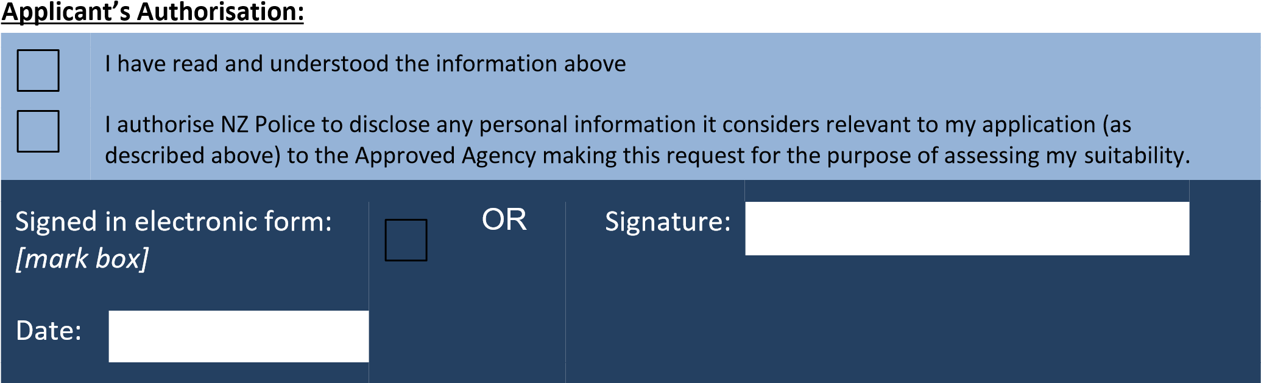

Section 3:
Applicant to complete for Australian check (if required)

ADDITIONAL PERSONAL INFORMATION (for Australian National Police History Check)

Last Permanent Australian Residential Address

 | Number/Street:
 | Suburb: |  |  |  |  |  |  |  | Post Code:
 | City/Town/  Rural District: |  |  |  |  |  |  |  |  |  | State or Territory:
Period of
Residence
If actual dates of residence are unavailable, year of residence will suffice

 | Australian Driver's Licence No: (if applicable) |  |  |  |  | Issued by:
Australian Firearms Licence No:
(if applicable)
 |  |  |  |  |  |  |  | Issued by:
CONSENT TO DISCLOSURE
General Information for an Australian National Police History Check

GENERAL INFORMATION  CrimTrac is collecting your personal information in this form in order to conduct a National Police History Check (NPHC) on you. Approved Agencies in New Zealand, named in section one, use the personal information collected on this form and the resulting NPHC as part of the assessment process to determine suitability for the position/entitlement/benefit which you are applying for.  Unless statutory obligations require otherwise, the information provided on this form will not be used without your prior consent for any purpose other than in relation to the assessment of your suitability or to maintain the records of CrimTrac, Australian Police Agencies, or NZ Police.  You will be required to complete another consent form for any future NPHC checks.  NATIONAL POLICE HISTORY CHECK (NPHC)  A NPHC is an integral part of the assessment of your suitability. Information on this form will be used by CrimTrac, and Australian Police Agencies for checking action; it will also be used to update records held about you by CrimTrac, Australian Police Agencies and NZ Police.  Information released may include outstanding charges, warrant information and criminal convictions/findings/pleas of guilt recorded against you that may be disclosed according to the laws of the relevant jurisdiction and, in the absence of any laws governing the release of that information, according to the relevant jurisdiction information release policy. | LIMITATIONS ON ACCURACY AND USE OF  POLICE HISTORY INFORMATION  While every care has been taken by CrimTrac to conduct a search of information held by Australian Police Agencies that relate to the applicant, the accuracy and quality of this NPHC depends on accurate identification of the Applicant (including aliases) according to the information provided in the Request and Consent Form and the comprehensiveness of police records. If the applicant does not complete the information requirements in this form the success and validity of the NPHC will be compromised.  If for any reason you do not agree with the results of your NPHC, please notify the Approved Agency that you submitted the check through in the first instance, so that the NPHC dispute process can be initiated.  The release of information by Australian Police Agencies is subject to relevant Spent Convictions, non-disclosure legislation or information release policies.
General Information for an Australian National Police History Check, continued

SPENT CONVICTIONS SCHEMES  The aim of Spent Convictions legislation is to prevent discrimination on the basis of certain previous convictions. Spent Convictions legislation limits the use and disclosure of older, less serious convictions and findings of guilt. Each Australian Police Agency will apply the relevant Spent Convictions legislation/information release policy prior to disclosure.  The following links may be helpful in sourcing information on Spent Convictions in the Australian States & Territories but may not be relied upon.  If further information or clarification is required please contact the individual Australian Police Agencies directly for further information about their release policies and any legislation that affects them.  Commonwealth www.comlaw.gov.au  New South Wales www.legislation.nsw.gov.au  Queensland  www.legislation.qld.gov.au  South Australia  www.legislation.sa.gov.au  Victoria Police www.police.vic.gov.au  Western Australia www.slp.wa.gov.au  Northern Territory  www.nt.gov.au/dcm/legislation/current.html  Australian Capital Territory www.legislation.act.gov.au  Tasmania  www.thelaw.tas.gov.au | PROVISION OF INCOMPLETE, FALSE OR  MISLEADING INFORMATION  An Approved Agency or Applicant must take reasonable steps to ensure that the personal information collected, or disclosed is accurate, complete and up to date.  You are asked to certify that the personal information you have provided on this form is correct. If it is subsequently discovered, for example as a result of a check of police records, that you have provided incomplete, false or misleading information, you may be assessed as unsuitable.  It is a serious offence to provide false or misleading information in Australia.
Section 3: continued
Applicant to complete for Australian check (if required)

CONSENT TO DISCLOSURE (for Australian National Police History Check)

I acknowledge, understand and consent as follows:
- I have read the General Information in section 3 of this form and understand that information will be disclosed in accordance with applicable legislation and information release policies (including spent convictions legislation, however described) in the Commonwealth, States and Territories;
- I understand that the position/entitlement for which I am being considered may be in a category for which exclusions from Spent Convictions legislation may apply;
- I have fully completed this form, and the personal information I have provided in it relates to me, contains my full name and all names previously used by me, and is correct;
- I acknowledge that the provision of false or misleading information is a serious offence;
- I acknowledge that the Approved Agency named in Section 1 of this form is collecting information in this Form to provide to NZ Police to provide to CrimTrac (an Agency of the Commonwealth of Australia) and the Australian Police Agencies;
- I consent to:
  - CrimTrac using and disclosing personal information about me in this form to the Australian Police Agencies;
  - the Australian Police Agencies disclosing to CrimTrac, from their records, Police History information that can be disclosed in accordance with the laws of the Commonwealth, States and Territories and in accordance with the relevant jurisdiction’s information release policies;
  - CrimTrac disclosing the information disclosed by the Australian Police Agencies to NZ Police, and
  - NZ Police disclosing any criminal history information about me to the Approved Agency named in Section 1 of this form to assess my suitability in relation to my application;
- I acknowledge that any information provided by me in this form relates specifically to the purpose identified in Section 1 of this form;
- I acknowledge that any information provided by the Australian Police Agencies or CrimTrac relates specifically to the purpose identified in Section 1 above;
- I acknowledge that personal information that I provide in this form may be disclosed to the Approved Agency named in Section 1 of this form (including contractors or related bodies corporate) located in New Zealand or overseas; and
- I acknowledge that it is usual practice for an Applicant's personal information in this form to be disclosed to NZ Police and Australian Police Agencies for them to use for their respective law enforcement purposes including the investigation of any outstanding criminal offences.

Note: The information provided in this form will be used only for the purpose stated above unless statutory obligations require otherwise.

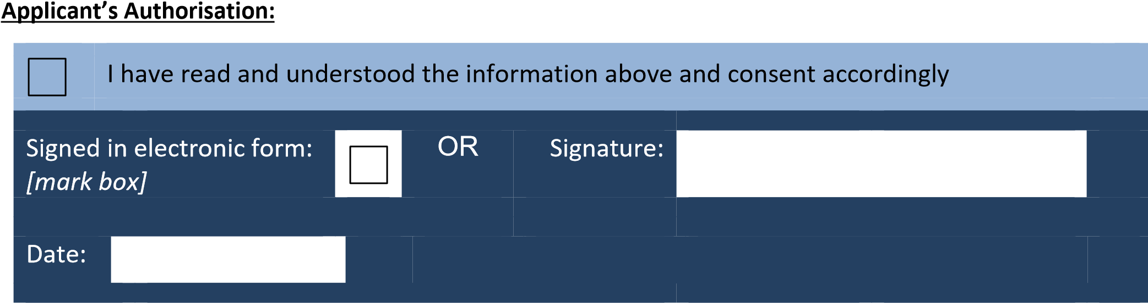

Australian Federal Police, ACT Policing, The New South Wales Police Force, Queensland Police Service, South Australia Police, Victoria Police, Western Australia Police, Northern Territory Police Force, Tasmania Police Service
Applicable Spent Conviction legislation, as amended from time to time

